Homework 2

Jacob Taylor Cassady

Semiconductor Development Fundamentals

January 21, 2020

# Name one acceptor dopant element for silicon.

boron (B)

# Name two donor dopant elements for silicon.

phosphorus (P)

arsenic (As)

# A piece of Silicon is doped with donor atoms at a concentration of 𝑁𝐷=10^18cm-3. The piece is 1 mm long, 10 micro-m wide, and 10 micro-m thick.

## What is the electron concentration?

no = ND

no = 10^18 cm^-3

## What is the hole concentration?

po = 10^20 / 10^18 = 10^2 cm^-3

## What is the electron mobility?

261.2876456325601

## What is the hole mobility?

143.210411376502

## What is the resistivity?

436420783930902.25 Ohms/cm^3

## Where is the Fermi level located relative to the middle of the bandgap?

The Fermi level is above (closer to Ec) the middle of the bandgap.

## What is the resistance of the piece of silicon?

43642078.393090226 Ohms

## 1V is applied across the length. How much current flows?

2.2913665820240317e-08 Amps

## 1000V is applied across the length. How much current flows?

2.2913665820240317e-05 Amps

# A piece of silicon is doped with acceptor atoms at a concentration of 𝑁𝐴=10^17cm-3. The piece is 10 micro-m long, 2 micro-m wide, and 2 micro-m thick.

## What is the electron concentration?

1e+17 cm^-3

## What is the hole concentration?

1000.0 cm^-3

## What is the electron mobility?

780.5038835154212

## What is the hole mobility?

330.82492639961237

## What is the resistivity?

0.18892167733608006 Ohms/cm^3

## Where is the Fermi level located relative to the middle of the bandgap?

The fermie level is located below (closer to Ev) the middle of the band gap.

## What is the resistance of the piece of silicon?

7.556867093443203e-12 Ohms

## 1V is applied across the length. How much current flows?

132329970559.84494 Amps

## 1000V is applied across the length. How much current flows?

132329970559844.94 Amps

# Using equations 3.35, 3.36, and 3.37, plot the intrinsic carrier concentration as a function of temperature for silicon. The temperature should range from 200K to 600K. The y-axis (intrinsic carrier concentration) should be a log scale. Use a computer to generate the plot and turn in your code.

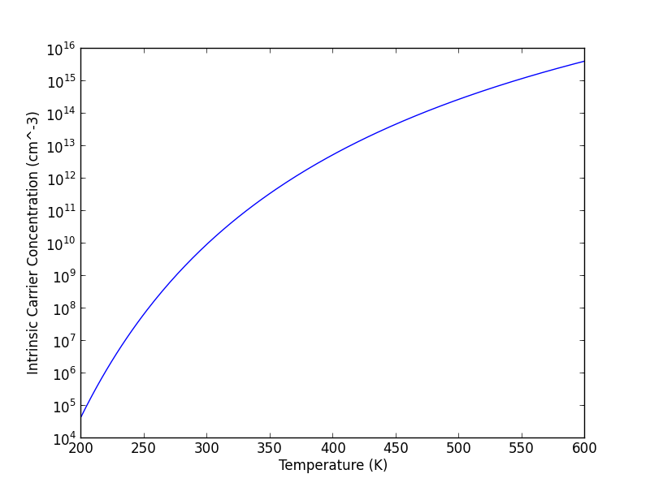

# Appendix

## Source Code